ARTIFICIAL INTELLIGENCE ASSESSMENT – 2 REPORT
Course Code: CSA1704 – Artificial
Intelligence Submitted By
Name: M Pradeepthi
Register Number: 192472387
Department: CSE-AI
Acknowledgement
I express my sincere gratitude to my faculty members and the Department of
Computer Science and Engineering for providing me with the opportunity to complete this Artificial Intelligence Assessment successfully. I also thank my friends and family members for their continuous encouragement and support throughout the completion of this work. Finally, I thank everyone who directly or indirectly contributed to the successful completion of this assessment.
Table of Contents
1. Introduction
2. Objective
3. Question 1 – Hospital Doctor Scheduling using Backtracking Search 4. Question 2 – Robot Navigation using Breadth First Search
5. Question 3 – Autonomous Rescue Robot using Online Search and Uniform Cost Search
6. Python Implementation
7. Program Outputs
8. Conclusion
G. References
Question 1 – Hospital Doctor Scheduling using Backtracking Search
Problem Statement
A hospital needs to assign three doctors (D1, D2, and D3) to three work shifts namely Morning, Afternoon, and Night. Each doctor must be be assigned exactly one shift while satisfying the given scheduling constraints. The objective is to determine a valid schedule using the Backtracking Search Algorithm. This problem demonstrates the application of Constraint Satisfaction Problems (CSP) in Artificial Intelligence for solving scheduling and resource allocation problems efficiently.
Solution
The Hospital Doctor Scheduling problem is solved using the Backtracking Search algorithm. The algorithm assigns shifts to doctors one by one while checking all the given constraints. Whenever a constraint is violated, the algorithm returns to the previous assignment and tries another possible shift. This process continues until a valid schedule satisfying all the constraints is obtained.
State Representation
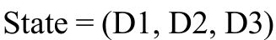
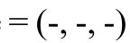Initial State = (-, -, -)
Goal State = (Morning, Afternoon, Night)
Constraints
• D1 cannot work in the Night shift.
• D2 must be assigned before D3.
• D3 cannot work in the Morning shift.
• Only one doctor can be assigned to each shift.
Architecture
Start
↓
Assign Shift
↓
Check Constraints
↓
Constraint Satisfied
↓
Yes → Assign Next Doctor
↓
No → Backtrack
↓
Goal State
Python Code:
doctors = ["D1", "D2", "D3"]
# List of available shifts
shifts = ["Morning", "Afternoon", "Night"]
# Dictionary to store final assignment
assignment = {}
# ---------------------------------------
# Function to check whether assignment is valid # ---------------------------------------
def is_safe(doctor, shift):
# Constraint 1:
# One shift should not be assigned twice
if shift in assignment.values():
return False
# Constraint 2:
# D1 cannot work Night shift
if doctor == "D1" and shift == "Night":
return False
# Constraint 3:
# D2 cannot work Morning shift
if doctor == "D2" and shift == "Morning":
return False
return True
def backtrack(index):
# Base condition
if index == len(doctors):
return True
# Current doctor
doctor = doctors[index]
# Try every shift
for shift in shifts:
print(f"Trying {doctor} -> {shift}")
# Check constraints
if is_safe(doctor, shift):
# Assign shift
assignment[doctor] = shift
print("Assigned:", assignment)
# Recursive call
if backtrack(index + 1):
return True
# Backtracking
print("Backtracking from", doctor)
del assignment[doctor]
return False
if backtrack(0):
print("\nValid Schedule")
for doctor, shift in assignment.items():
print(doctor, "->", shift)
else:
print("No valid schedule found.")
Result
The Backtracking Search algorithm successfully generates a valid doctor schedule by satisfying all the given constraints.
Question 2 – Robot Navigation using Breadth First Search Problem
Statement
A robot is placed in a 5 × 5 grid environment where it has to move from the Start position to the Goal position while avoiding obstacles. The robot can move only in four directions namely Up, Down,
Left, and Right. Each movement has a cost of one unit. The objective is
to determine the shortest path using the Breadth First Search (BFS) algorithm. This problem demonstrates the application of AI search techniques in robot navigation and path planning.
Solution
The Robot Navigation problem is solved using the Breadth First Search (BFS) algorithm. The algorithm starts from the initial position and explores all neighbouring nodes level by level using a queue. Since every movement has the same cost, BFS always finds the shortest path from the start node to the goal node.
State Representation
State = (Current Position)
Initial State = Start Node (S) Goal
State = Goal Node (G)
Operators
• Move Up
• Move Down
• Move Left
• M o v e
Right
Architecture
Start Node
↓
Generate Successor Nodes
↓
Queue
↓
Expand Node
↓
Goal Test
↓
Goal Reached
Python Code:
from collections import deque
# 5x5 Grid
grid = [
['S', '.', '.', '#', '.'],
['.', '#', '.', '#', '.'],
['.', '#', '.', '.', '.'],
['.', '.', '#', '#', '.'],
['#', '.', '.', 'G', '.']
]
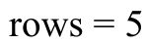
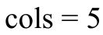
# Find Start and Goal positions
for i in range(rows):
for j in range(cols):
if grid[i][j] == 'S':
start = (i, j)
elif grid[i][j] == 'G':
goal = (i, j) 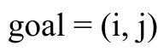
# Possible movements
directions = [
(-1, 0), # Up
(1, 0), # Down
(0, -1), # Left
(0, 1) # Right
]
# BFS Function
def bfs(start, goal):
queue = deque()
queue.append((start, [start]))
visited = set()
visited.add(start)
while queue:
current, path = queue.popleft()
print("Current Node:", current)
print("Queue:", list(queue))
if current == goal:
return path
for dx, dy in directions:
x = current[0] + dx
y = current[1] + dy
if 0 <= x < rows and 0 <= y < cols:
if grid[x][y] != '#' and (x, y) not in visited:
visited.add((x, y))
queue.append(((x, y), path + [(x, y)]))
return None
# Driver Code
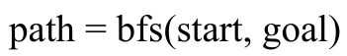
if path:
print("\nShortest Path:")
print(path)
print("\nTotal Cost =", len(path) - 1)
else:
print("No Path Found")
Result
The Breadth First Search algorithm successfully identifies the shortest path from the start
node to the goal node.

Question 3 – Autonomous Rescue Robot using Online Search and Uniform Cost Search Problem Statement
An autonomous rescue robot is deployed in a disaster-affected area to locate survivors safely. The robot operates in a partially observable environment containing blocked paths and risky zones. It continuously senses the environment, updates its knowledge, and
selects the least-cost path to reach the survivor. This problem demonstrates the use of Online Search Agents and Uniform Cost Search in intelligent decision-making.
Solution
The rescue robot is implemented as an Online Search Agent. It continuously collects information from the environment using sensors and updates its internal knowledge base.
The Uniform Cost Search (UCS) algorithm is used to identify the least-cost path by expanding the node with the minimum cumulative cost first. This enables the robot to reach the survivor efficiently while minimizing the total travel cost.
Environment
• Safe Area
• Blocked Area
• Risk Zone
• Survivor Location
Actions
• Move Forward
• Turn Left
• Turn Right
• Sense Environment
• Update Knowledge
• Rescue
Survivor
Architecture
Environment
↓
Sensors
↓
Knowledge Base
↓
Uniform Cost Search
↓
Decision Making
↓
Actuators
↓
Survivor Reached
Python Code:
import heapq
# 5x5 Grid
grid = [
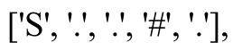 ['S', '.', '.', '#', '.'],
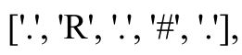 ['.', 'R', '.', '#', '.'],
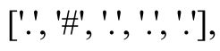 ['.', '#', '.', '.', '.'],
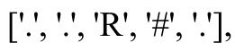 ['.', '.', 'R', '#', '.'],
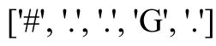 ['#', '.', '.', 'G', '.']
]
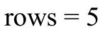
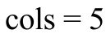
# Find Start and Goal
for i in range(rows):
for j in range(cols):
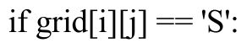 if grid[i][j] == 'S':
start = (i, j)
elif grid[i][j] == 'G':
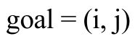 goal = (i, j)
# Possible moves
directions = [
(-1, 0), # Up
(1, 0), # Down
(0, -1), # Left
(0, 1) # Right
]
# Uniform Cost Search Function
def uniform_cost_search(start, goal):
# Priority Queue
pq = []
# (cost, current_position, path)
heapq.heappush(pq, (0, start, [start]))
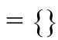 visited = {}
while pq:
cost, current, path = heapq.heappop(pq)
print("Current Node:", current)
print("Current Cost:", cost)
if current == goal:
return path, cost
if current in visited and visited[current] <= cost:
continue
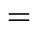 visited[current] = cost
for dx, dy in directions:
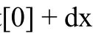 x = current[0] + dx
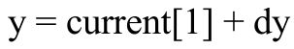 y = current[1] + dy
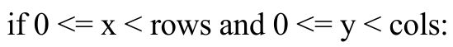 if 0 <= x < rows and 0 <= y < cols:
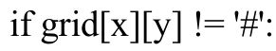 if grid[x][y] != '#':
# Normal move cost
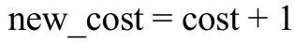 new_cost = cost + 1
# Extra cost for risky zone
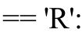 if grid[x][y] == 'R':
new_cost += 2
heapq.heappush(
pq,
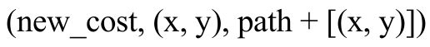 (new_cost, (x, y), path + [(x, y)])
)
return None, None
# Driver Code
path, cost = uniform_cost_search(start, goal)

if path:
print("\nMinimum Cost Path:")
print(path)
print("Total Cost =", cost)
else:
print("No Path Found")
Result
The Online Search Agent successfully reaches the survivor by selecting the minimum-cost path using the Uniform Cost Search algorithm.

